CO-5 PROGRAMS OUTPUTS
import { BrowserRouter, Routes, Route, Link } from 'react-router-dom';
function Home() {
return <h1>Home Page</h1>;
}
function About() {
return <h1>About Page</h1>;
}
function Contact() {
return <h1>Contact Page</h1>;
}
function App() {
return (
<>
<nav>
<Link to="/">Home</Link> |{" "}
<Link to="/about">About</Link> |{" "}
<Link to="/contact">Contact</Link>
</nav>
<Routes>
<Route path="/" element={<Home />} />
<Route path="/about" element={<About />} />
<Route path="/contact" element={<Contact />} />
</Routes>
</>
);
}
export default App;
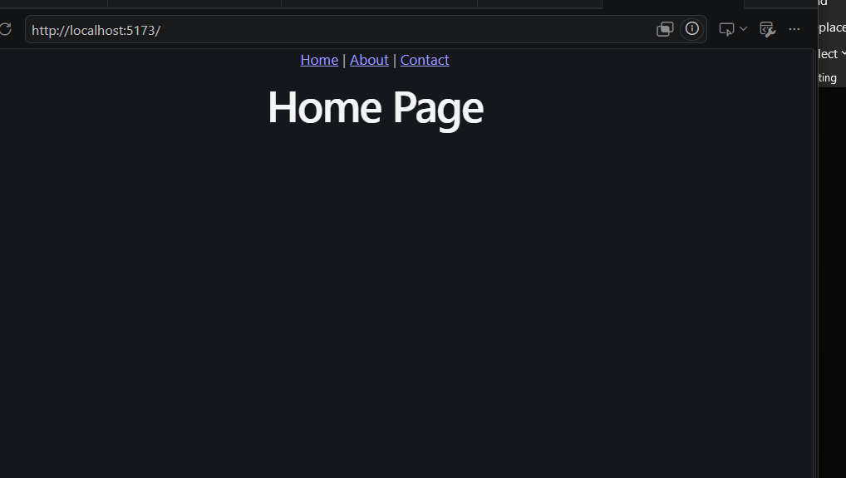
Nested routing example
import React from 'react';
import { BrowserRouter, Routes, Route, Link, Outlet } from 'react-router-dom';
function Home() {
return <h1>Home Page</h1>;
}
function Products() {
return (
<div>
<h1>Products Page</h1>
<nav style={{ marginBottom: '20px' }}>
<Link to="/products/car">Cars</Link> |{" "}
<Link to="/products/bike">Bikes</Link>
</nav>
<Outlet />
</div>
);
}
function CarProducts() {
return (
<div>
<h2>Cars</h2>
<ul>
<li>Audi</li>
<li>BMW</li>
<li>Volvo</li>
</ul>
</div>
);
}
function BikeProducts() {
return (
<div>
<h2>Bikes</h2>
<ul>
<li>Yamaha</li>
<li>Suzuki</li>
<li>Honda</li>
</ul>
</div>
);
}
function Contact() {
return <h1>Contact Page</h1>;
}
function App() {
return (
<BrowserRouter>
{/* Navigation */}
<nav>
<Link to="/">Home</Link> |{" "}
<Link to="/products">Products</Link> |{" "}
<Link to="/contact">Contact</Link>
</nav>
{/* Routes */}
<Routes>
<Route path="/" element={<Home />} />
<Route path="/products" element={<Products />}>
<Route path="car" element={<CarProducts />} />
<Route path="bike" element={<BikeProducts />} />
</Route>
<Route path="/contact" element={<Contact />} />
</Routes>
</BrowserRouter>
);
}
export default App;
NEXT PROGRAM:
import { Routes, Route } from "react-router-dom";
import Login from "../ProtectedRoutes/Login";
import Dashboard from "../ProtectedRoutes/Dashboard";
import ProtectedRoute from "../ProtectedRoutes/ProtectedRoute";
function App() {
return (
<Routes>
<Route
path="/"
element={<Login />}
/>
<Route
path="/dashboard"
element={
<ProtectedRoute>
<Dashboard />
</ProtectedRoute>
}
/>
</Routes>
);
}
export default App; 